In [1]:

**import pandas as pd import numpy as np import seaborn as sns**

**import matplotlib.pyplot as plt**

In [2]:

nesarc = pd.read_csv('nesarc.csv', low_memory=**False**) pd.set_option('display.float_format', **lambda** x:'**%f**'%**x**)

# From Prac 1

**Columns/Data used in Prac 1**

In [3]:

nesarc['S2AQ5B'] = pd.to_numeric(nesarc['S2AQ5B'], errors='coerce') *#convert variable t o numeric*

nesarc['S2AQ5D'] = pd.to_numeric(nesarc['S2AQ5D'], errors='coerce') *#convert variable t o numeric*

nesarc['S2AQ5A'] = pd.to_numeric(nesarc['S2AQ5A'], errors='coerce') *#convert variable t o numeric*

nesarc['S2BQ1B1'] = pd.to_numeric(nesarc['S2BQ1B1'], errors='coerce') *#convert variable to numeric*

nesarc['AGE'] = pd.to_numeric(nesarc['AGE'], errors='coerce') *#convert variable to nume ric*

# From Prac 2

**A subset of nesarc data, with the following criteria Age from 26 to 50**

# Beer drinking status - S2AQ5A = Y

In [4]:

sub1=nesarc[(nesarc['AGE']>=26) & (nesarc['AGE']<=50) & (nesarc['S2AQ5A']==1)] sub2=sub1.copy()

# From Prac 2

**SETTING MISSING DATA**

sub2['S2AQ5D']=sub2['S2AQ5D'].replace(99, np.nan)

sub2['S2AQ5B']=sub2['S2AQ5B'].replace(8, np.nan) sub2['S2AQ5B']=sub2['S2AQ5B'].replace(9, np.nan) sub2['S2AQ5B']=sub2['S2AQ5B'].replace(10, np.nan) sub2['S2AQ5B']=sub2['S2AQ5B'].replace(99, np.nan)

sub2['S2BQ1B1']=sub2['S2BQ1B1'].replace(9, np.nan)

# From Prac 2 Recode data

In [6]:

recode2 = {1:30, 2:26, 3:14, 4:8, 5:4, 6:2.5, 7:1}

sub2['BEER_FEQMO']= sub2['S2AQ5B'].map(recode2)

recode3 = {2:0, 1:1}

sub2['S2BQ1B1']= sub2['S2BQ1B1'].map(recode3)

# From Prac 2

**Create secondary variables**

In [7]:

*# A secondary variable multiplying the number of days beer consumed/month and the appro x number of*

*# beer consumed/day* sub2['NUMBEERMO_EST']=sub2['BEER_FEQMO'] * sub2['S2AQ5D']

# Draw a Line chart

**Age vs Number of beer consumed per month (NUMBEERMO_EST)**

# mean number of beer consumed

**var = mean number of beers consumed a month, grouped by age**

var = sub2.groupby(['AGE']).NUMBEERMO_EST.mean() print(var)

|  |  |
| --- | --- |
| AGE |  |
| 26 | 23.701357 |
| 27 | 23.854545 |
| 28 | 30.035270 |
| 29 | 23.994949 |
| 30 | 24.170530 |
| 31 | 25.541033 |
| 32 | 25.678994 |
| 33 | 24.761017 |
| 34 | 23.143713 |
| 35 | 28.668478 |
| 36 | 26.813272 |
| 37 | 28.530387 |
| 38 | 26.414773 |
| 39 | 27.307122 |
| 40 | 31.571023 |
| 41 | 23.233788 |
| 42 | 31.877676 |
| 43 | 28.045455 |
| 44 | 37.279762 |
| 45 | 27.067241 |
| 46 | 31.727799 |
| 47 | 33.204918 |
| 48 | 33.655303 |
| 49 | 28.177778 |
| 50 | 28.995614 |

Name: NUMBEERMO_EST, dtype: float64

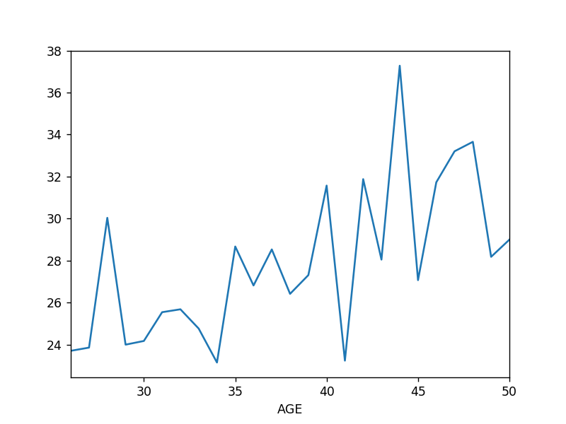In [30]:

%**matplotlib** notebook var.plot(kind='line')

Out[30]:

<matplotlib.axes._subplots.AxesSubplot at 0x6c1b8552b0>

# total number of beer consumed

**var2 = sum number of beers consumed a month,**

In [10]:

var2 = sub2.groupby(['AGE']).NUMBEERMO_EST.sum() print(var2)

|  |  |  |
| --- | --- | --- |
| AGE |  |  |
| 26 | 5238.000000 |
| 27 | 6560.000000 |  |
| 28 | 7238.500000 |  |
| 29 | 7126.500000 |  |
| 30 | 7299.500000 |  |
| 31 | 8403.000000 |  |
| 32 | 8679.500000 |  |
| 33 | 7304.500000 |  |
| 34 | 7730.000000 |  |
| 35 | 7912.500000 |  |
| 36 | 8687.500000 |  |
| 37 | 10328.000000 |  |
| 38 | 9298.000000 |  |
| 39 | 9202.500000 |  |
| 40 | 11113.000000 |  |
| 41 | 6807.500000 |  |
| 42 | 10424.000000 |  |
| 43 | 8021.000000 |  |
| 44 | 9394.500000 |  |
| 45 | 7849.500000 |  |
| 46 | 8217.500000 |  |
| 47 | 8102.000000 |  |
| 48 | 8885.000000 |  |
| 49 | 6340.000000 |  |
| 50 | 6611.000000 |  |
| Name: | NUMBEERMO_EST, | dtype: float64 |

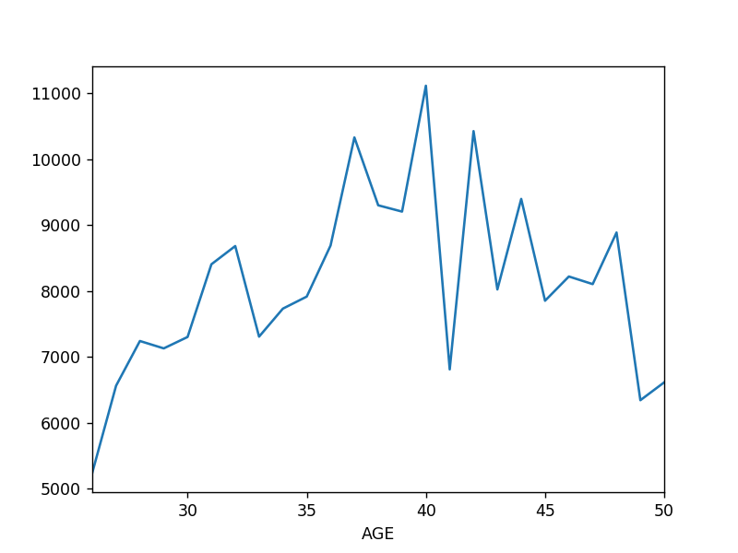In [31]:

fig = plt.figure() var2.plot(kind='line')

Out[31]:

<matplotlib.axes._subplots.AxesSubplot at 0x6c06ab77f0>

# Draw a stacked Column Chart x = age (AGE)

**y = number of beers consumed per month (NUMBEERMO_EST)**

# stack is based on depedency on beer (S2BQ1B1)

**var3 = mean number of beers consumed a month, grouped by age and beer depedency (S2BQ1B1)**

var3 = sub2.groupby(['AGE','S2BQ1B1']).NUMBEERMO_EST.sum() print(var3)

|  |  |  |
| --- | --- | --- |
| AGE | S2BQ1B1 |  |
| 26 | 0.000000 | 4225.500000 |
|  | 1.000000 | 949.000000 |
| 27 | 0.000000 | 6000.000000 |
|  | 1.000000 | 560.000000 |
| 28 | 0.000000 | 5542.500000 |
|  | 1.000000 | 1686.500000 |
| 29 | 0.000000 | 5363.500000 |
|  | 1.000000 | 1675.000000 |
| 30 | 0.000000 | 5942.500000 |
|  | 1.000000 | 1244.000000 |
| 31 | 0.000000 | 7185.500000 |
|  | 1.000000 | 1212.500000 |
| 32 | 0.000000 | 7352.500000 |
|  | 1.000000 | 1288.500000 |
| 33 | 0.000000 | 6279.000000 |
|  | 1.000000 | 901.500000 |
| 34 | 0.000000 | 6672.000000 |
|  | 1.000000 | 1039.500000 |
| 35 | 0.000000 | 7264.500000 |
|  | 1.000000 | 518.000000 |
| 36 | 0.000000 | 7190.000000 |
|  | 1.000000 | 1420.000000 |
| 37 | 0.000000 | 7765.000000 |
|  | 1.000000 | 2531.000000 |
| 38 | 0.000000 | 7962.000000 |
|  | 1.000000 | 1294.000000 |
| 39 | 0.000000 | 8519.000000 |
|  | 1.000000 | 667.500000 |
| 40 | 0.000000 | 10030.500000 |
|  | 1.000000 | 1022.500000 |
| 41 | 0.000000 | 6047.000000 |
|  | 1.000000 | 755.500000 |
| 42 | 0.000000 | 9352.500000 |
|  | 1.000000 | 986.500000 |
| 43 | 0.000000 | 7061.000000 |
|  | 1.000000 | 695.000000 |
| 44 | 0.000000 | 7711.500000 |
|  | 1.000000 | 1186.000000 |
| 45 | 0.000000 | 6839.000000 |
|  | 1.000000 | 865.500000 |
| 46 | 0.000000 | 7180.000000 |
|  | 1.000000 | 925.500000 |
| 47 | 0.000000 | 5938.500000 |
|  | 1.000000 | 1949.000000 |
| 48 | 0.000000 | 6971.500000 |
|  | 1.000000 | 1913.500000 |
| 49 | 0.000000 | 5799.500000 |
|  | 1.000000 | 491.000000 |
| 50 | 0.000000 | 5341.500000 |
|  | 1.000000 | 1230.500000 |

Name: NUMBEERMO_EST, dtype: float64

var3.unstack().plot(kind='bar', stacked=**True**, color=['red','blue'], grid=**False**)

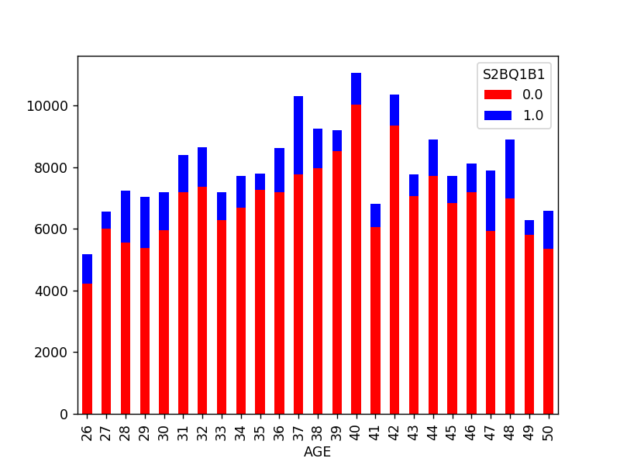

Out[32]:

<matplotlib.axes._subplots.AxesSubplot at 0x6c0885bd68>

# Draw a horizontal stacked Column Chart x = age (AGE)

**y = number of beers consumed per month (NUMBEERMO_EST)**

# stack is based on depedency on beer (S2BQ1B1)

var3.unstack().plot(kind='barh', stacked=**True**, color=['red','blue'], grid=**False**)

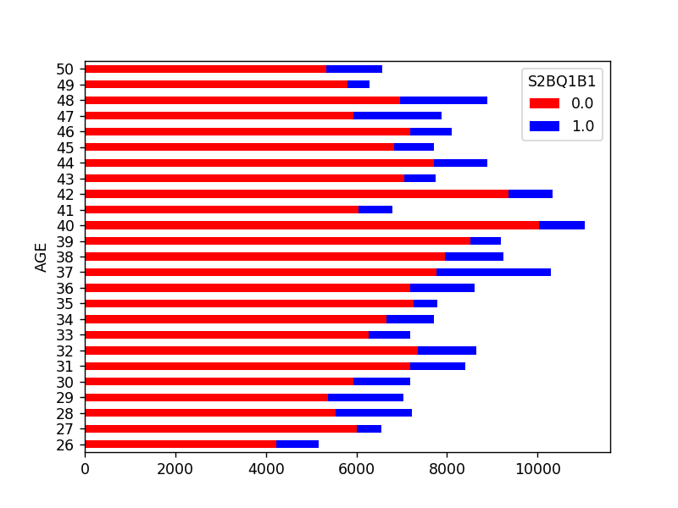

Out[33]:

<matplotlib.axes._subplots.AxesSubplot at 0x6c14836588>

# Draw a Pie Chart showing age (AGE) and total beer consumed a month (NUMBEERMO_EST)

**hint use var2**

print(var2)

|  |  |  |
| --- | --- | --- |
| AGE |  |  |
| 26 | 5238.000000 |
| 27 | 6560.000000 |  |
| 28 | 7238.500000 |  |
| 29 | 7126.500000 |  |
| 30 | 7299.500000 |  |
| 31 | 8403.000000 |  |
| 32 | 8679.500000 |  |
| 33 | 7304.500000 |  |
| 34 | 7730.000000 |  |
| 35 | 7912.500000 |  |
| 36 | 8687.500000 |  |
| 37 | 10328.000000 |  |
| 38 | 9298.000000 |  |
| 39 | 9202.500000 |  |
| 40 | 11113.000000 |  |
| 41 | 6807.500000 |  |
| 42 | 10424.000000 |  |
| 43 | 8021.000000 |  |
| 44 | 9394.500000 |  |
| 45 | 7849.500000 |  |
| 46 | 8217.500000 |  |
| 47 | 8102.000000 |  |
| 48 | 8885.000000 |  |
| 49 | 6340.000000 |  |
| 50 | 6611.000000 |  |
| Name: | NUMBEERMO_EST, | dtype: float64 |

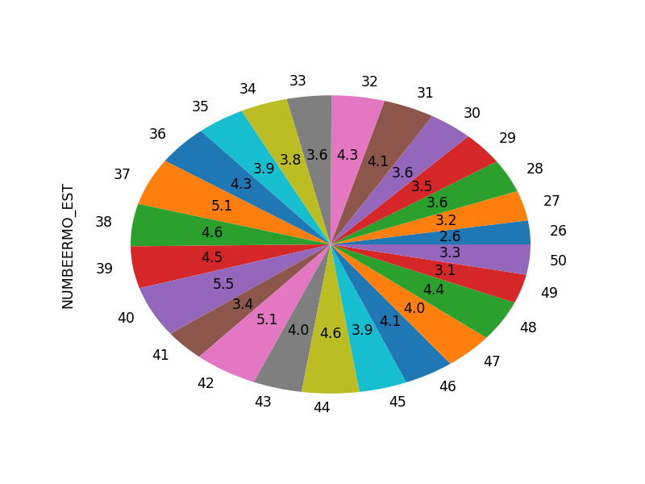In [34]:

fig = plt.figure() var2.plot(kind='pie',autopct='**%.1f**')

Out[34]:

<matplotlib.axes._subplots.AxesSubplot at 0x6c14d07e10>

# Draw a Violin Plot for age (AGE) and income (S1Q10A)

**convert income (S1Q10A) to numeric**

In [17]:

sub2['S1Q10A'] = pd.to_numeric(nesarc['S1Q10A']) *#convert variable to numeric*

# Plot violin plot

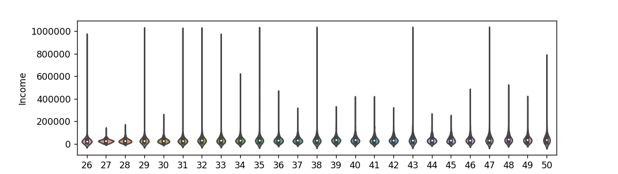In [35]:

fig = plt.figure()

sns.violinplot(x='AGE', y='S1Q10A', data=sub2) plt.xlabel('Age')

plt.ylabel('Income')

Out[35]:

Text(0,0.5,'Income')

# Draw a HeatMap for Ethnicity and Carton of Beer consumed per month, based on depedency on beer

**Rename Race - From Module 4**

In [19]:

*# you can rename categorical variable values for graphing if original values are not in formative*

*# first change the variable format to categorical if you haven’t already done so* sub2['ETHRACE2A'] = sub2['ETHRACE2A'].astype('category')

sub2['ETHRACE2A']=sub2['ETHRACE2A'].cat.rename_categories(["White", "Black", "NatAm", "Asian", "Hispanic"])

# Create a new variable CARTON_ADAY using CARTON_ADAY function provided

In [20]:

**def** CARTON_ADAY (row):

**if** row['BEER_FEQMO'] >= 30 :

**return** 1

**elif** row['BEER_FEQMO'] < 30 : **return** 0

sub2['CARTON_ADAY'] = sub2.apply (**lambda** row: CARTON_ADAY (row),axis=1)

# Print the size of CARTON_ADAY, grouped by category

In [21]:

c4= sub2.groupby('CARTON_ADAY').size() print(c4)

|  |  |
| --- | --- |
| CARTON_ADAY |  |
| 0.000000 | 6897 |
| 1.000000 | 417 |
| dtype: int64 |  |

# Draw bar chart to show relationship between race (ETHRACE2A) and CARTON_ADAY

*# bivariate bar graph C->C*

%**matplotlib** notebook

sns.factorplot(x='ETHRACE2A', y='CARTON_ADAY', data=sub2, kind="bar", ci=**None**) plt.xlabel('Ethnic Group')

plt.ylabel('Proportion of consumed a carton a day Beer Drinkers')

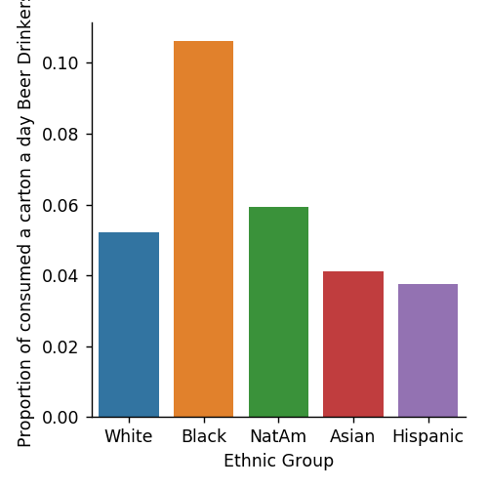

Out[36]:

Text(0.694444,0.5,'Proportion of consumed a carton a day Beer Drinkers')

# Make copy of just race (ETHRACE2A) and CARTON_ADAY

sub3 = sub2[['ETHRACE2A','CARTON_ADAY']].copy()

sub3.head()

Out[23]:

|  |  |  |
| --- | --- | --- |
|  | **ETHRACE2A** | **CARTON_ADAY** |
| **1** | Hispanic | nan |
| **8** | White | nan |
| **12** | Asian | 0.000000 |
| **16** | White | nan |
| **24** | Hispanic | nan |

# Create pivot table of race (ETHRACE2A) and CARTON_ADAY

In [24]:

table = pd.pivot_table(sub3, index=['ETHRACE2A'], columns=['CARTON_ADAY'], aggfunc=np.s ize)

print(table)

|  |  |  |
| --- | --- | --- |
| CARTON_ADAY  ETHRACE2A | 0.000000 | 1.000000 |
| Asian | 374 | 16 |
| Black | 1972 | 234 |
| Hispanic | 2914 | 114 |
| NatAm | 222 | 14 |
| White | 8312 | 456 |

# Draw heat map

fig = plt.figure() sns.heatmap(table)

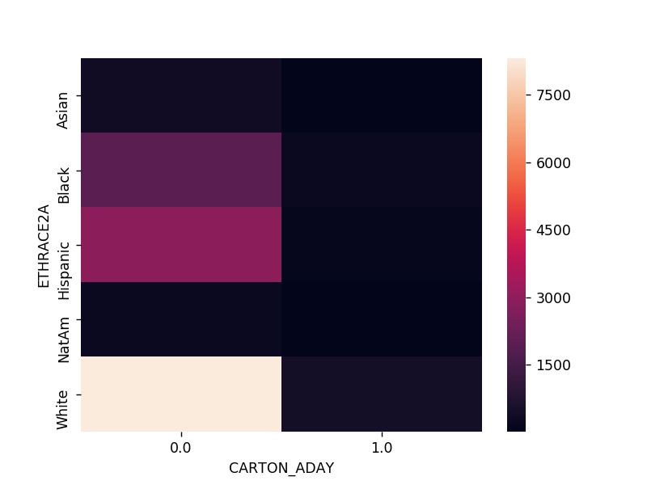

Out[37]:

<matplotlib.axes._subplots.AxesSubplot at 0x6c05e2a9e8>

# Draw a bubble Chart Read in gapminder.csv

pd.set_option('display.float_format', **lambda** x:'**%.2f**'%**x**)

gapminder = pd.read_csv('gapminder.csv', low_memory=**False**) gapminder.head()

Out[26]:

|  |  |  |  |  |  |
| --- | --- | --- | --- | --- | --- |
|  | **country** | **incomeperperson** | **alcconsumption** | **armedforcesrate** | **breastcancerper** |
| **0** | Afghanistan |  | .03 | .5696534 | 26.8 |
| **1** | Albania | 1914.99655094922 | 7.29 | 1.0247361 | 57.4 |
| **2** | Algeria | 2231.99333515006 | .69 | 2.306817 | 23.5 |
| **3** | Andorra | 21943.3398976022 | 10.17 |  |  |
| **4** | Angola | 1381.00426770244 | 5.57 | 1.4613288 | 23.1 |

# Convert internetuserate, urbanrate and incomeperperson to numeric

In [27]:

gapminder['internetuserate'] = pd.to_numeric(gapminder['internetuserate'],errors='coerc e')

gapminder['urbanrate'] = pd.to_numeric(gapminder['urbanrate'],errors='coerce') gapminder['incomeperperson'] = pd.to_numeric(gapminder['incomeperperson'],errors='coerc e')

In [28]:

gapminder_clean=gapminder.dropna()

# Draw a bubble Chart x = urbanrate

**y = income per person bubble size = internetuserate**

*# x = internetuserate # y = incomeperperson*

*# Added third variable income as size of the bubble*

%**matplotlib** notebook fig = plt.figure()

plt.scatter(gapminder_clean['incomeperperson'],gapminder_clean['urbanrate'], s=gapminde r_clean['internetuserate'])

plt.xlabel('Ubran Rate') plt.ylabel('Income Per Person')

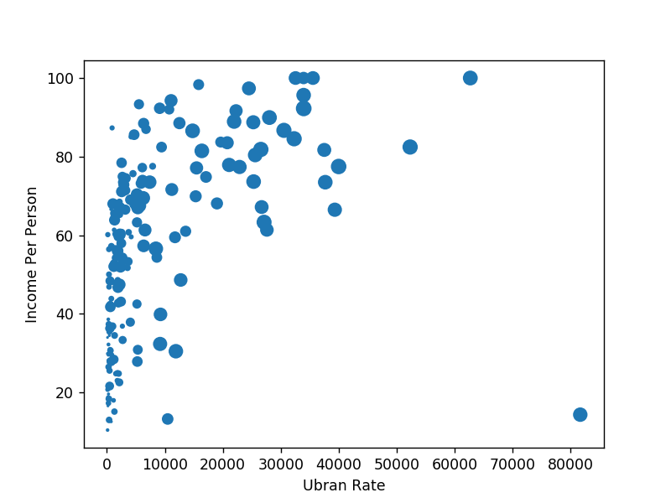

Out[29]:

Text(0,0.5,'Income Per Person')